AWS Infrastructure: A Complete Overview

Cloud computing has changed the way organizations build, deploy, and manage applications. Amazon Web Services (AWS) is one of the leading cloud platforms, offering a secure, scalable, and highly available infrastructure. To effectively use AWS, it is important to understand its core infrastructure concepts such as regions, availability zones, virtualization, and hypervisors.
This blog provides a detailed overview of AWS Infrastructure and its key components.
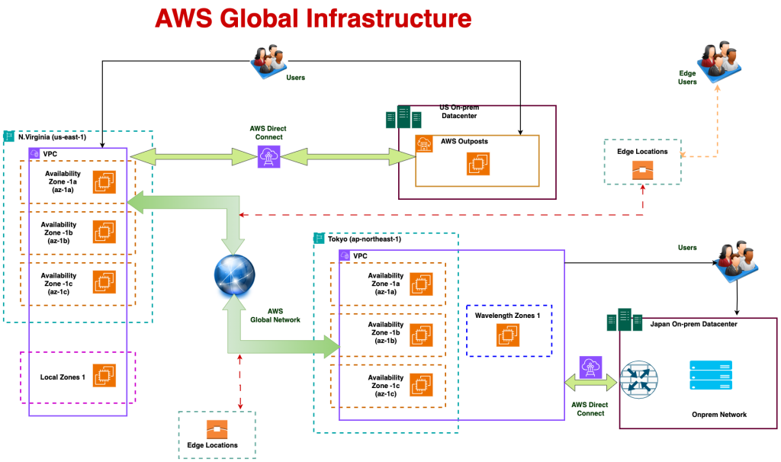

1. Infrastructure in Cloud Computing
What is Infrastructure?
Infrastructure refers to the fundamental resources required to run IT systems and applications. These resources include computing power, storage, networking, and system software.
Infrastructure in AWS
AWS provides infrastructure as a service (IaaS), where the physical infrastructure is fully managed by AWS. Users can provision and manage virtual resources on demand without owning hardware.
Importance of Infrastructure
- Forms the foundation of all cloud services
- Enables scalability and flexibility
- Reduces hardware and maintenance costs
- Provides secure and reliable environments

2. Regions in Cloud Computing
What is a Region?
A cloud region is a geographic location where a cloud provider operates multiple data centres. In AWS, each region is completely isolated from others.
Uses of Regions
- Hosting applications closer to users
- Meeting data residency and compliance requirements
- Disaster recovery and backup planning
Importance of Regions
- Low Latency: Improves application performance
- Compliance: Helps meet legal and regulatory requirements
- Fault Isolation: Failures in one region do not affect others
- Global Reach: Enables worldwide application deployment

3. Availability Zones (AZs)
What are Availability Zones?
An Availability Zone (AZ) is a physically separate data center within a cloud region. Each AWS region consists of two or more AZs connected by high-speed, low-latency networks.

Uses of Availability Zones
- Distributing application components
- Building fault-tolerant architectures
- Ensuring continuous application availability
Importance of Availability Zones
- High Availability: Applications remain accessible during failures
- Fault Tolerance: Prevents single points of failure
- Business Continuity: Minimizes downtime and data loss

4. Virtualization
What is Virtualization?
Virtualization is a technology that allows multiple virtual machines (VMs) to run on a single physical server by abstracting hardware resources.
Uses of Virtualization
- Running multiple applications on the same hardware
- Rapid provisioning of servers
- Testing and development environments
- Efficient resource management
Importance of Virtualization
- Maximizes hardware utilization
- Enables fast scaling of resources
- Provides isolation between workloads
- Reduces infrastructure costs
Virtualization is the backbone of AWS compute services, enabling flexibility and scalability.

5. Hypervisor
What is a Hypervisor?
A hypervisor is a software layer that enables virtualization by creating and managing virtual machines on physical servers.
Uses of Hypervisors
- Allocating CPU, memory, and storage to VMs
- Managing VM lifecycle
- Ensuring isolation and security between workloads
Importance of Hypervisors
- Improves performance and resource efficiency
- Enhances security through isolation
- Enables scalable and automated infrastructure
- Supports cloud-level virtualization
AWS uses advanced hypervisors such as Xen and AWS Nitro to deliver high-performance and secure compute services.

Conclusion
AWS Infrastructure provides a strong and reliable foundation for modern cloud applications. By leveraging global regions, multiple availability zones, virtualization, and advanced hypervisors, AWS ensures high availability, scalability, and security.
Understanding these core concepts helps organizations design resilient architectures, optimize performance, and reduce operational complexity. AWS infrastructure enables businesses to innovate faster while maintaining reliability and cost efficiency.

